**Audrey Long**

**Project 3**

**Measurement and Transmission of Propeller Speed**

**02/23/2020**

**Project Description**

* Project 3 Measure and Transmit Fan Speed and Thrust
* Follow the instructions in Arduino-Based Optical Tachometer by CMPalmer to measure the speed of a brushless propeller which is driven by an Arduino and measured using an IR Emitter/Detector pair measured by the Arduino using either Round Robbin with Interrupts or Function Queue Scheduling.
* Capture the RPMs over time, download to a Host and create a graph of the RPMs.
* If you don’t have a propeller to be able to measure RPMs, use something else like a kid’s Fidget or even a pencil.
* Submit per directions in “Project Submission.docx”

**Requirements**

* Follow the directions provided by CMPalmer
* Design code driven around round robin with interrupts
* Create a system on the bread board with an IR transmitter and IR receiver facing each other with room in between to insert a propeller.
* Create a system with a propeller
* Capture the RPM data in the serial terminal
* Create graph of RPMs

**Embedded System Design**

*Figure 1: Embedded system IR photo transistor and IR LED setup*

Pictured above is the embedded IR photo transistor and IR LED system setup. Figure 2 below demonstrates the IR photo transistor is attached by a 10 kΩ resistor connected to digital pin 2. The IR LED is connected to digital pin 13. Figure 2 also illustrates the secondary system used to generate the brushless propeller power; It is being connected to a 9V battery with a 100 Ω resistor to reduce the fan speed. Figure 3 showcases the wiring diagram.

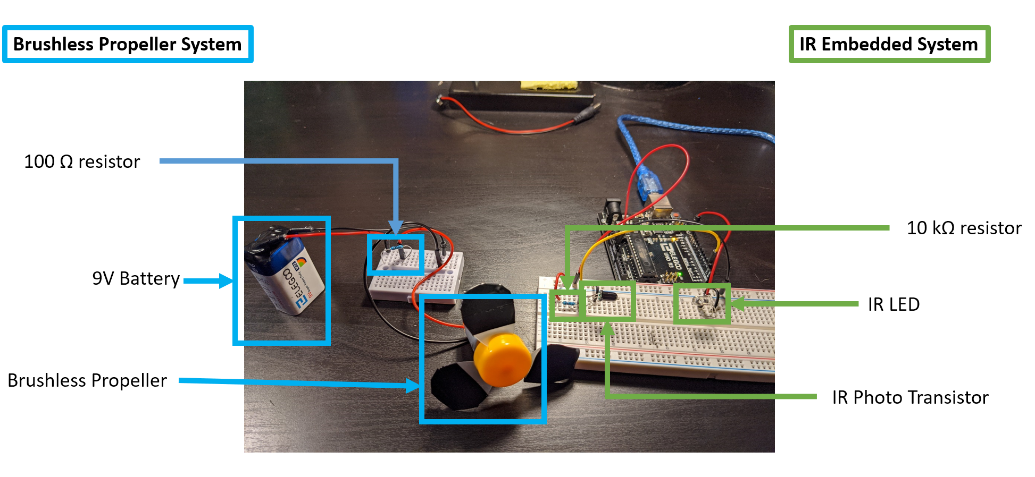

*Figure 2: Full system design*

*Figure 3: Arduino hookups*

The following wire diagram illustrates the wires and ports chosen for this embedded system:

* + 5v POWER
  + Ground
  + Digital pin 13
  + Digital pin 2

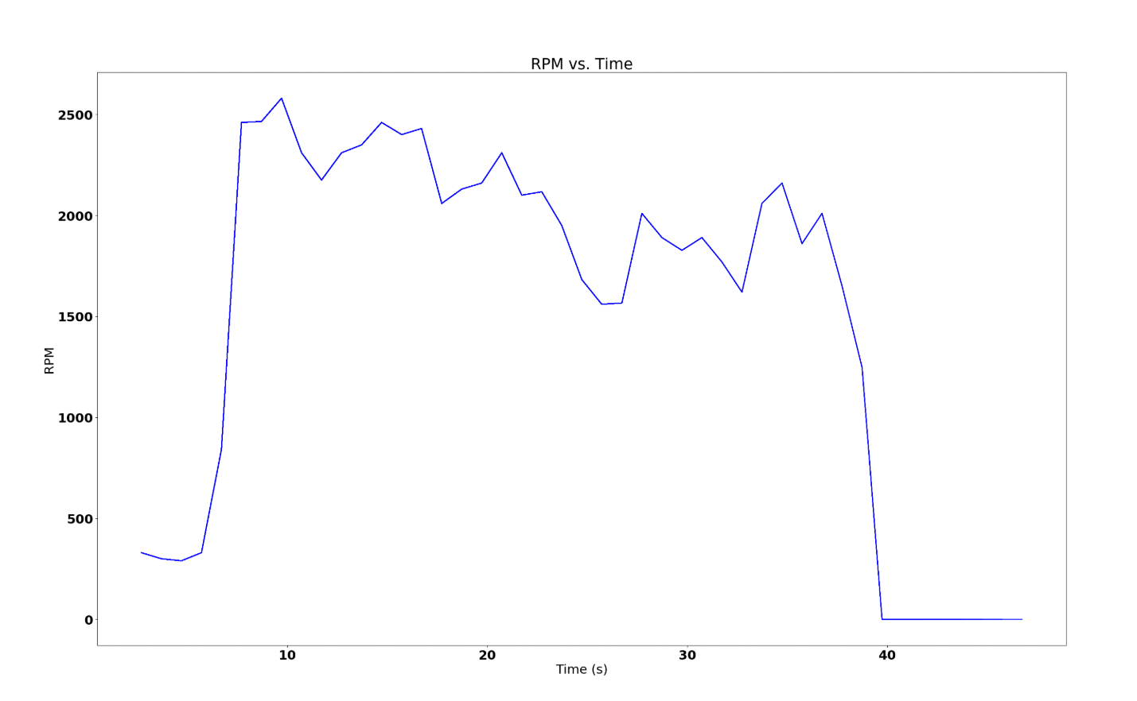

*Figure 4: RPM vs. Time graph*

The figure 4 graph above shows the graph RPM vs. Time results which were gathered by the Serial.py python script attached in the project. This program grabs the serial data being transmitted from the embedded system and generated a real time graph of the data.

**Additional Information**

**Code Base**

Please refer to my GitHub:

<https://github.com/cheesemuffinish/Embedded_Projects/tree/master/Project3_Propeller_IR>

**Video**

Please refer to my YouTube:

<https://www.youtube.com/watch?v=bFoI9u3tvMA&t=105s>